1)Introduction and Purpose
Name of Application : PhotoSite Web Application
Youtube URL : https://www.youtube.com/watch?v=y6b1klzM3FA&feature=youtu.be

2)Demonstration of Application working

The below screen shot shows the page that is displayed when /user/index URL is accessed. This page displays a list of users with links to the first names of users.

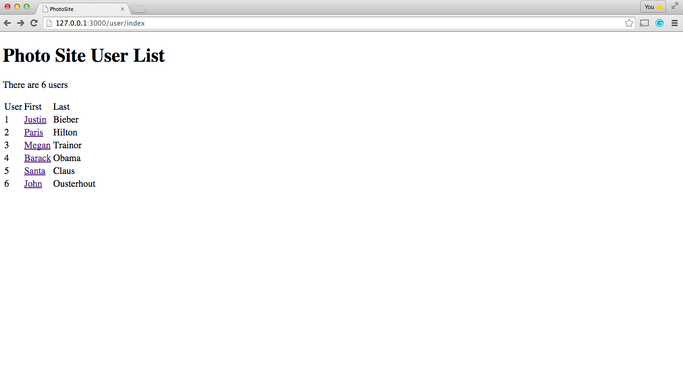

The below screen shot appears when the link Justin is clicked on the above screen which goes to a page “/photo/index/1”. This screen shot displays all the photos of user Justin Bieber with the following details. Photo creation time, all the comments posted for his photos, user who posted the comments and comment creation time. Link will be given to the user name who posted the comments. From this link one can access the photos of the user who posted comments.

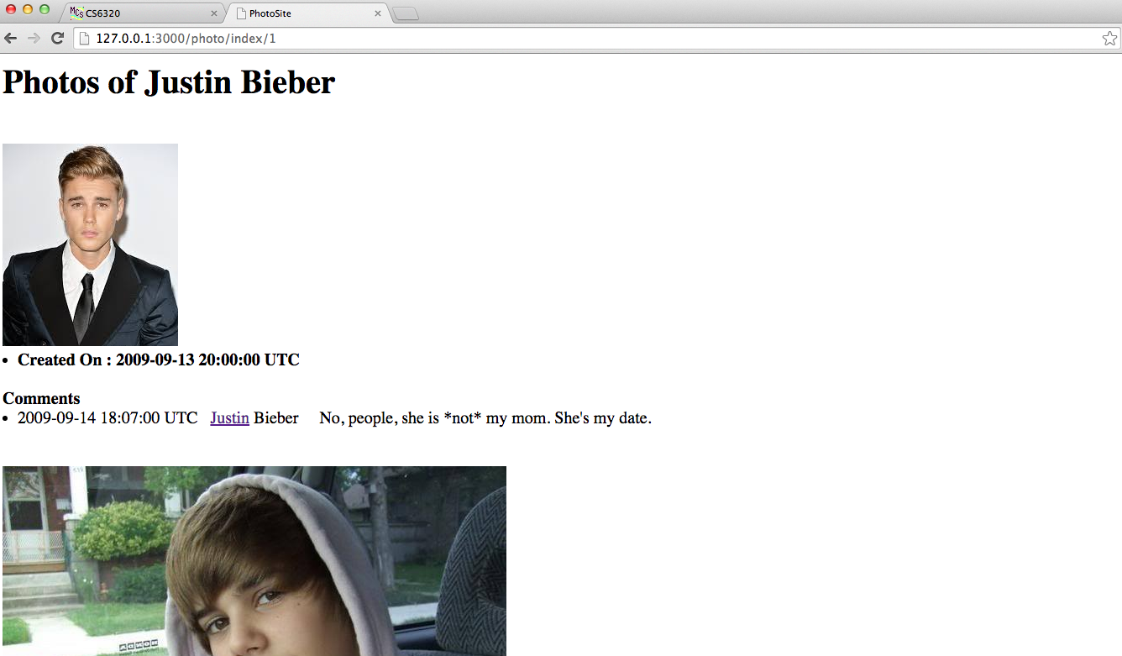

The below screen shot appears when the link Paris is clicked in the first page. This displays all the photos of user Paris with comments. As you can see, John posted a comment to the second photo. We can access John's photos by clicking the link to his name.

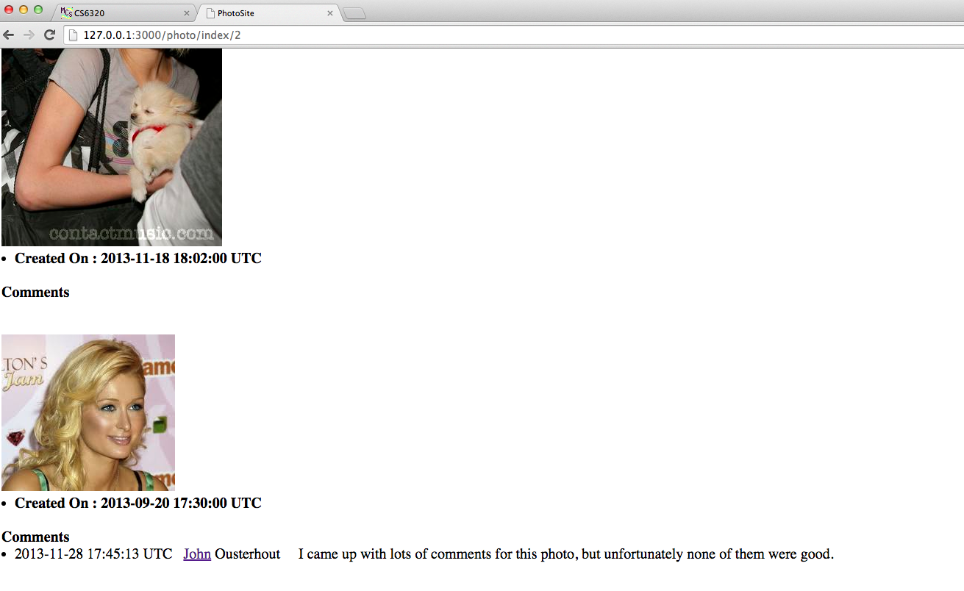
The below screen shot appears when link John is clicked on the above screen shot. This page displays all photos of user John.
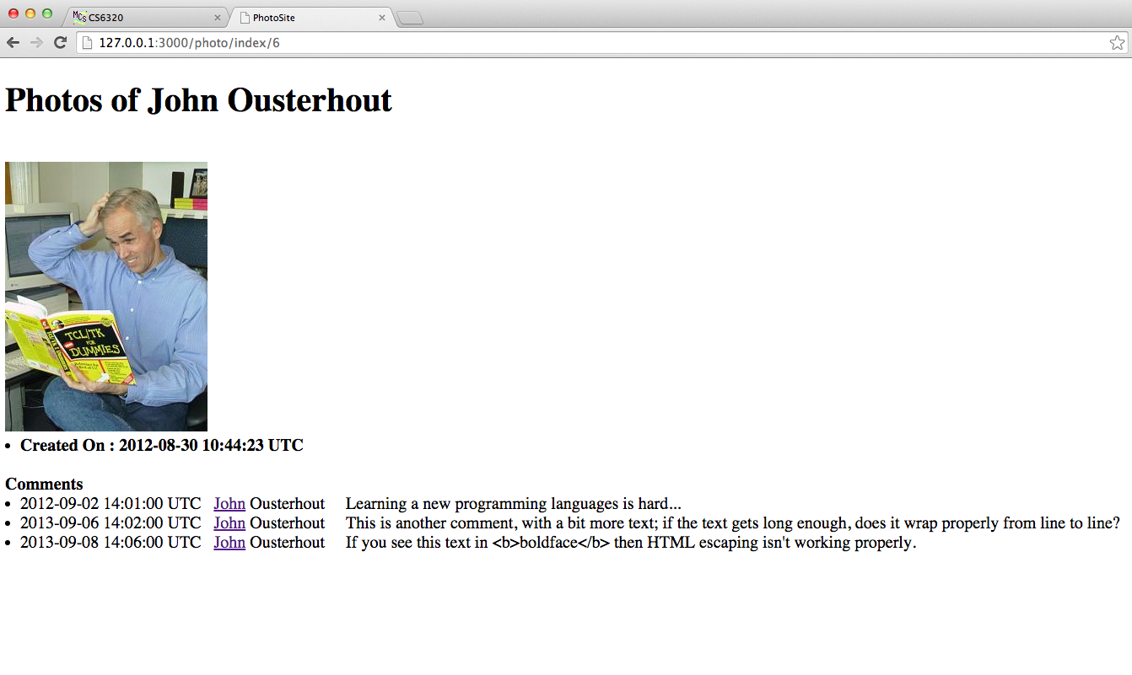
The below screen shot appears when the link Barack is clicked on first page(/user/index).
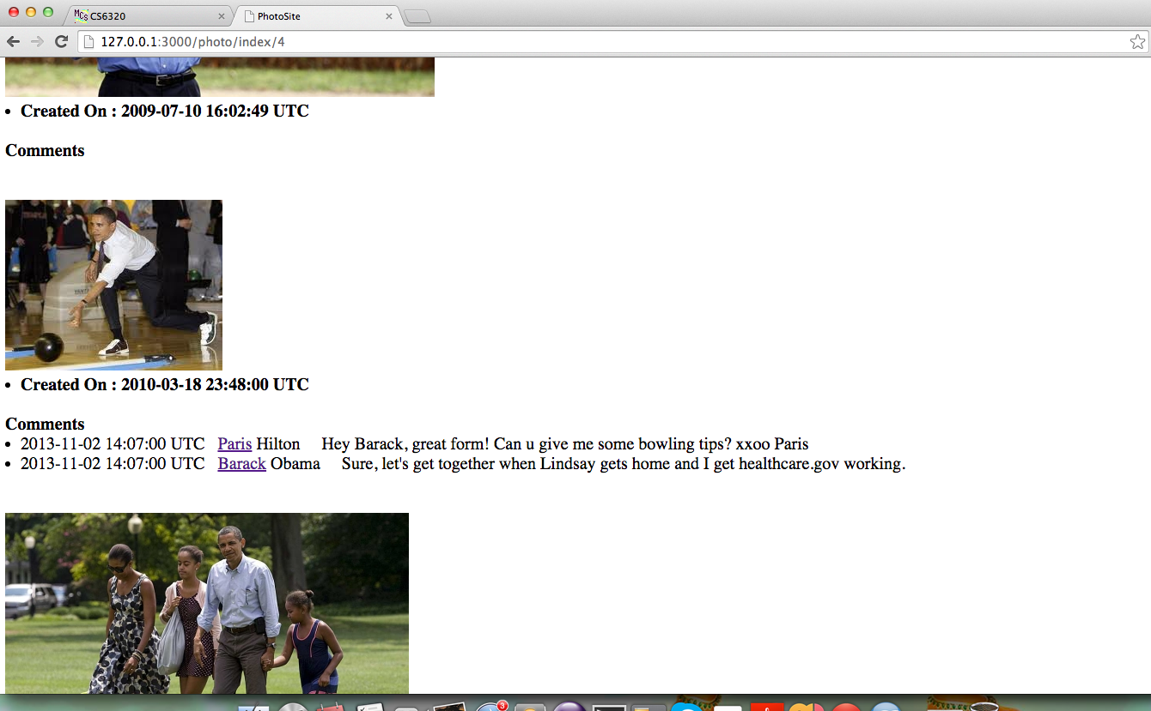
The below screen shot appears when link Santa is clicked on first page(/user/index)
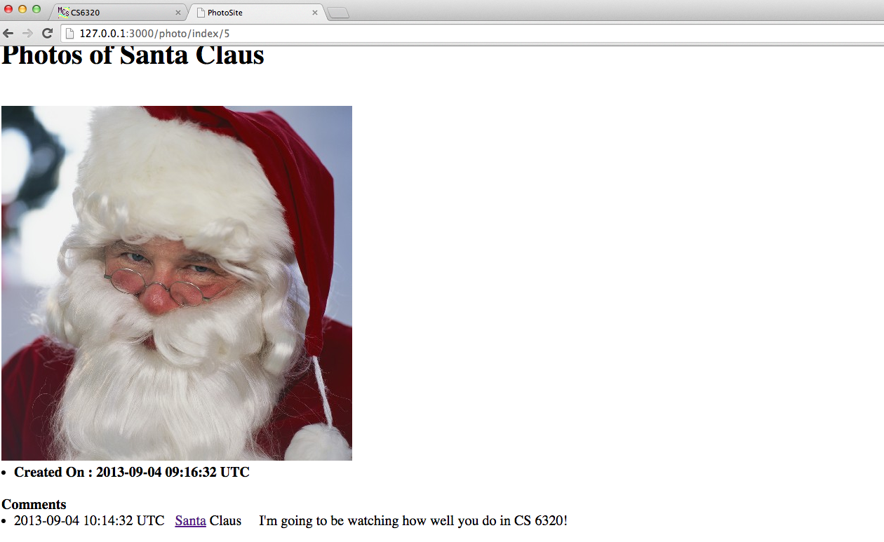

The below screen shot appears when the link Megan is clicked on first page(/user/index).
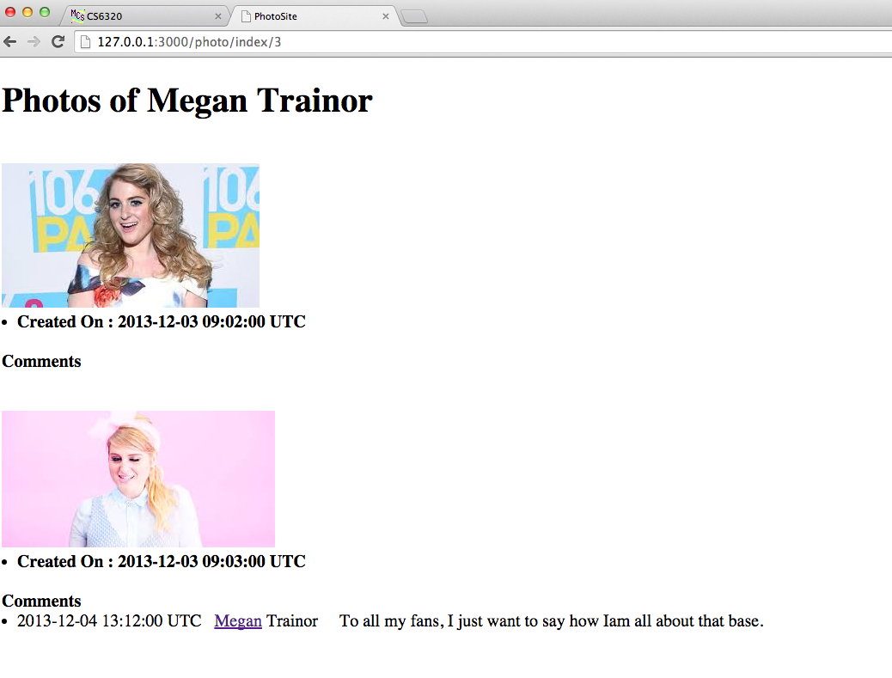
3) Discussion of anything NOT working
Application is working fine as per requirements.

